Assignment-1

SMART HOME

Team ID: PNT2022TMID21342

NAME: KRISHNA PRASANNA V G

# Circuit:

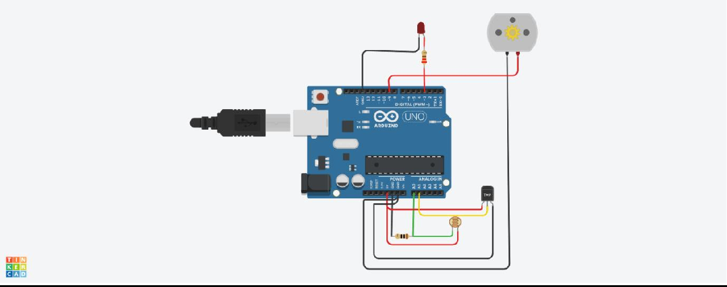

**Components required:**

1. Arduino UNO
2. LED 3.Temperature Sensor
3. Resister – 10 Ω, 221 Ω
4. Photoresistor
5. DC motor (used in place of FAN)

# Code:

int ldr=A0;//Set A0(Analog Input) for LDR. int led = 3;

int value=0; void setup() {

Serial.begin(9600); pinMode(led,OUTPUT); // initialize serial pinMode(9,OUTPUT); pinMode(A1,INPUT);

}

void loop(){

float temperature;

temperature=analogRead(A1);

float tempmv=temperature*5000/1024; float tempc=(tempmv/10)+(-50);

value=analogRead(ldr);//Reads the Value of LDR(light). Serial.println("LDR value is :");//Prints the value of LDR to Serial Monitor. Serial.println(value);

if(value<10)

{

digitalWrite(led,HIGH);//Makes the LED glow in Dark.

}

else

{

digitalWrite(led,LOW);//Turns the LED OFF in Light.

}

if(tempc<20)

{

analogWrite(9,0); delay(1000);

}

else if(tempc>20&&tempc<=25)

{

analogWrite(9,100); delay(1000);

}

else if(tempc>25&&tempc<=30)

{

analogWrite(9,150); delay(1000);

}

else

{

analogWrite(9,255);

delay(1000);

}

}